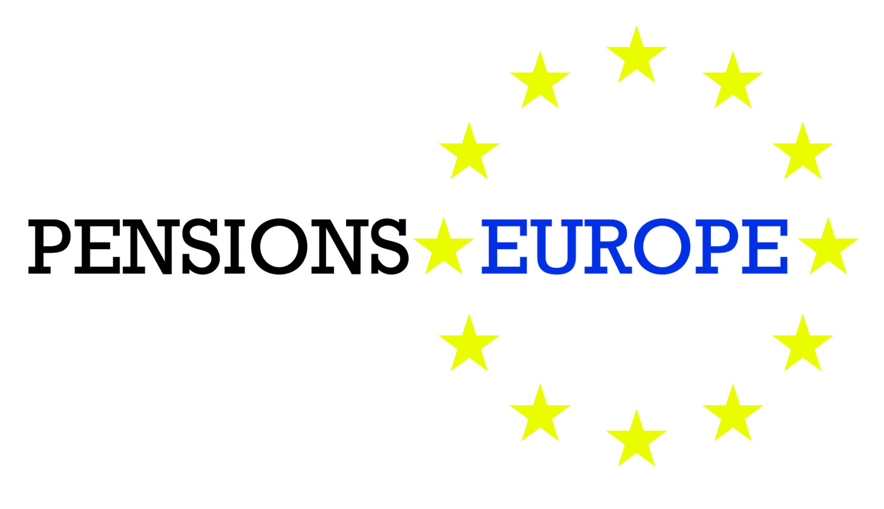

30 October 2015

Questionnaire:

Impact of EU financial legislation on pension funds

Please provide us with your answers to the questionnaire below on the cumulative impact of EU financial legislation by 25 November.

Your answers will allow us to prepare a draft PensionsEurope answer to the Commission’s call for evidence on the cumulative impact of EU financial legislation (which closes on 6 January) as well as to write a Position Paper on the impact of EU financial legislation on pension funds.

For the answers, please provide supporting relevant and verifiable empirical evidence for your example (please give references to concrete examples, reports, literature references, data, etc.) and suggestions to remedy the issue(s) raised in your example, please make them here.

Questionnaire – Impact of EU financial legislation

1. Unnecessary regulatory constraints on financing

Are there any obstacles to the ability of pension funds to finance the economy, such as long-term innovation and infrastructure projects? Where possible, please provide quantitative estimates to support your assessment.

2 – Market liquidity

Please specify whether, and to what extent, the regulatory framework has had any major positive or negative impacts on market liquidity. Please elaborate on the relative significance of such impact in comparison with the impact caused by macroeconomic or other underlying factors.

3 – Investor and consumer protection

Please specify whether, and to what extent, the regulatory framework has had any major positive or negative impacts on investor and consumer protection and confidence.

4 – Proportionality / preserving diversity in the EU financial sector

Are EU rules adequately suited to the diversity of financial institutions in the EU? Are these rules adapted to the emergence of new business models and the participation of non-financial actors in the market place? Is further adaptation needed and justified from a risk perspective? If so, which, and how?

5 – Excessive compliance costs and complexity

In response to some of the practices seen in the run-up to the crisis, EU rules have necessarily become more prescriptive. This could increase costs and complexity, and weaken a sense of individual responsibility. Please identify and justify such burdens that, in your view, do not meet the objectives set out above efficiently and effectively. Please provide quantitative estimates to support your assessment and distinguish between direct and indirect impacts, and between one-off and recurring costs. Please identify areas where they could be simplified, to achieve more efficiently the intended regulatory objective.

6 – Reporting and disclosure obligations

The EU has put in place a range of rules designed to increase transparency and provide more information to regulators, investors and the public in general. In some areas the same or similar information may be required to be reported more than once, or requirements may result in information reported in a way which is not useful to provide effective oversight or added value for investors.

Are the current reporting and disclosure obligations are fit for the purpose of public oversight and ensuring transparency?

Please identify the reporting provisions, either publicly or to supervisory authorities, which in your view either do not meet sufficiently the objectives above or where streamlining/clarifying the obligations would improve quality, effectiveness and coherence. If applicable, please provide specific proposals.

7 – Contractual documentation

Standardised documentation is often necessary to ensure that market participants are subject to the same set of rules throughout the EU in order to facilitate the cross-border provision of services and ensure free movement of capital. When rules change, clients and counterparties are often faced with new contractual documentation. This may add costs and might not always provide greater customer/ investor protection.

Please identify specific situations where contractual or regulatory documents need to be updated with unnecessary frequency or are required to contain information that does not adequately meet the objectives above. Please indicate where digitalisation and digital standards could help to simplify and make contractual documentation less costly, and, if applicable, identify any obstacles to this happening.

8 – Rules outdated due to technological change

Please specify where the effectiveness of rules could be enhanced to respond to increasingly online-based services and the development of financial technology solutions for the financial services sector.

9 – Barriers to entry

Please document barriers to market entry arising from regulation that the EU should help address. Have the new rules given rise to any new barriers to entry for new market players to challenge incumbents or address hitherto unmet customer needs?

10 – Links between individual rules and overall cumulative impact
Given the interconnections within the financial sector, it is important to understand whether the rules on banking, insurance, asset management and other areas are interacting as intended. Please identify and explain why interactions may give rise to unintended consequences that should be taken into account in the review process.
Please provide an assessment of their cumulative impact. Please consider whether changes in the sectoral rules have affected the relevancy or effectiveness of the cross-sectoral rules (for example with regard to financial conglomerates). Please explain in what way and provide concrete examples.

11 – Definitions
Different pieces of financial services legislation contain similar definitions, but the definitions sometimes vary (for example, the definition of SMEs). Please indicate specific areas of financial services legislation where further clarification and/or consistency of definitions would be beneficial.

12 – Overlaps, duplications and inconsistencies
Please indicate specific areas of financial services legislation where there are overlapping, duplicative or inconsistent requirements.

13 – Gaps
While the recently adopted financial legislation has addressed the most pressing issues identified following the financial crisis, it is also important to consider whether they are any significant regulatory gaps. Please indicate to what extent the existing rules have met their objectives and identify any remaining gaps that should be addressed.

14 – Risk
EU rules have been put in place to reduce risk in the financial system and to discourage excessive risk-taking, without unduly dampening sustainable growth. However, this may have led to risk being shifted elsewhere within the financial system to avoid regulation or indeed the rules unintentionally may have led to less resilient financial institutions. Please indicate whether, how and why in your view such unintended consequences have emerged.

15 – Procyclicality
EU rules have been put in place to make the financial system less procyclical and more stable through the business and credit cycle. Please indicate whether some rules have unintentionally increased the procyclicality of the financial system and how.

